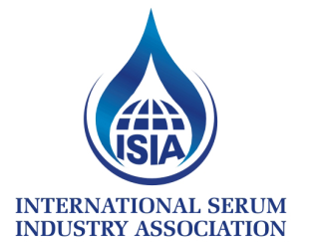
INTERNATIONAL SERUM
INDUSTRY ASSOCIATION
PO BOX 926, MCHENRY, MD 21541 USA
PHONE: 301 387 4967 FAX: 301 387 7560

TO: All ISIA Applicants
FROM: Stephen Judd
DATE: July 1, 2017
RE: Revenue Data Request for Dues Calculations

The Association has approved a wholly apportioned approach to dues assessment in which each member pays the same, set percentage of their self-reported revenues from serum. The exceptions to that this year are that (1) no member shall pay less than $1,100, (2) no member reporting revenue of less than $50MM will pay more than $25,000, and (3) no member reporting revenue in excess of $50MM will pay more than $29,000. This structure requires that each member report their revenues for the preceding fiscal year as defined by the following statements:

- This figure is to be derived only from end-user revenues for each member group or company. Internal transfers should not be included.
- Each member should draw this figure from their most recent audited financials.
- Each member should include only revenue generated from the sales of animal blood products for use in life science research, diagnostic kit production and/or the manufacturing of biopharmaceutical products and vaccines.

The ISIA has contracted with Maloney & Associates PLLC, an independent, third-party bookkeeper to collect this revenue data from all members, calculate proportionate dues, generate and distribute invoices to each member, and collect monies for transfer into the ISIA accounts. In this way, no one within the Association (except the CEO) will have any knowledge of the numbers submitted.

Accordingly, we would ask you to please complete and return the Dues Data Certification to the accountants who manage our dues calculations and invoicing. Email to Pam Schwer at Maloney & Associates. pam@maloneyandassociates.com

Dues for Associate Members is a flat fee of $4850.00 per year.

Best regards,

Stephen A. Judd
Treasurer/Chief Financial Officer

